Message – God the Father: My Son is Being Sent to Claim His Rightful Throne
December 24, 2011 @ 6:00 PM
Date of Input and Sharing – July 6, 2021

(Message)
My daughter, just as I sent a Savior into the world the first time to save humanity I am now ready to send My Son, Jesus the Redeemer of mankind, once again to salvage those souls who could not be otherwise saved. My children must understand the significance of the bitter sweet sacrifice I made for mankind when I sent My Son the first time. When I realized that the only way to redeem mankind was to send a Savior I knew I could not expect any prophet or chosen soul to suffer such a sacrifice.

I decided through the second person of My Divinity that I would send a Son to save humanity. This was the only effective way to foil the plans of Satan such was my love for My children. To watch My Son grow up to become a man was both delightful and painful knowing what lay ahead of Him. Yet because of the deep tender love I have for each of My children this was a sacrifice endured willingly in order to save My family.
- The Sacramental Principle. In our course in Liturgy we learned about the Sacramental Principle. The simple explanation is as follows:
- God is perfect and infinite and human beings are imperfect and finite (after Adam and Eve have fallen from grace). They have become imperfect and can no longer see God anymore. The sin of pride is the boundary that divides God and man. There has to be a perfect being who is worthy of saving mankind
- It was a “bitter sweet sacrifice I made for mankind when I sent My Son the first time. When I realized that the only way to redeem mankind was to send a Savior I knew I could not expect any prophet or chosen soul to suffer such a sacrifice.” And so Jesus was born of the Virgin Mary. Jesus came for the first time. This is the First Coming. The second person of the Trinity came. Jesus became a man; a human being with flesh and blood taken from the Virgin Mary. Jesus the God has become a God-Man. And Jesus throughout his ministry mingled with men who are sinners. Jesus is both human and divine, or both God and man
- There is a need for mankind to encounter God but due to our sinfulness and limitations we cannot qualify, and no one else qualifies if we stand before the face of God
- The point of encounter between God who is infinite and men who are finite is the HUMANITY OF JESUS CHRIST
- So there is no one else on earth who can do the role of redemption for the lost children of God. No one else, because the Redeemer has to be perfect in order to save humanity from ruin
- The point at which this divine encounter occurs is the point of sacramental encounter; and for us Christians, the point of sacramental encounter with God is THE HUMANITY OF JESUS CHRIST
- The infinite God is now available for all of us because Jesus came both as God and man. This was the 1st Coming of our Lord. Illustration as below:

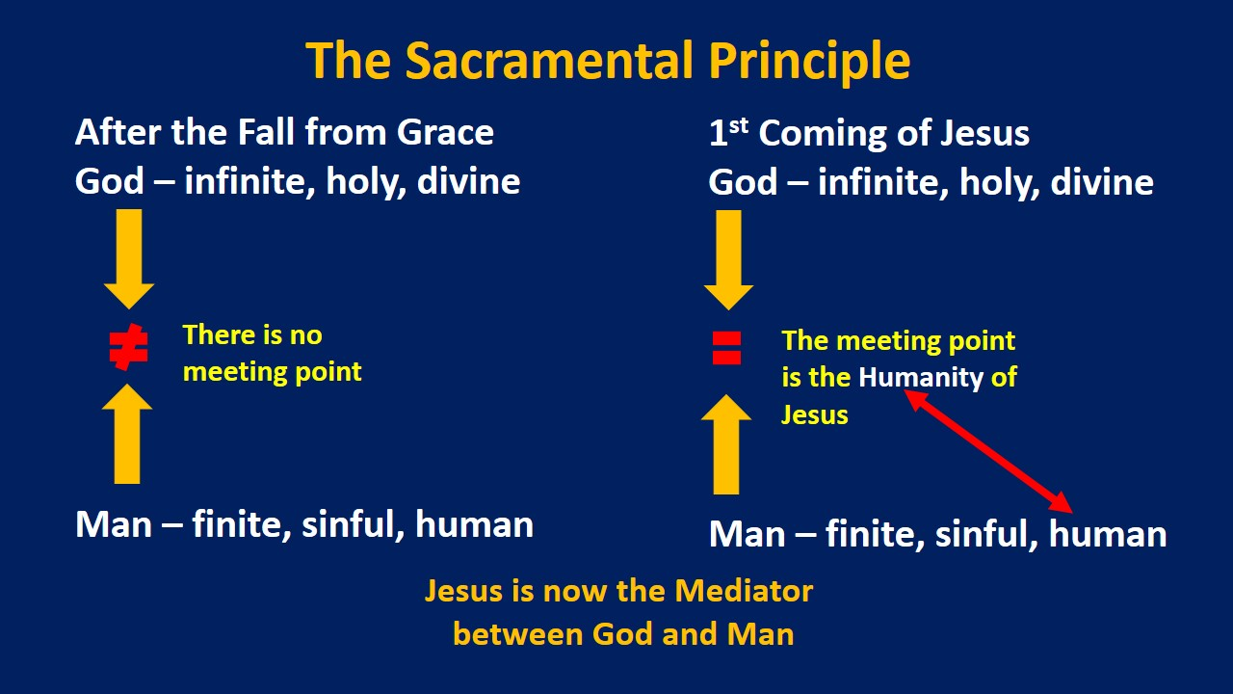

(Back to Message)
Now that The Warning approaches I am also preparing the World, through these Holy messages, to welcome My Son for the Second Time. The Second Coming of My beloved Son is close children. He is being sent to claim his rightful throne when He will reign as King of Mankind.
- So now, we are now in the period of the 2nd Coming of our Lord and the 2nd coming is preceded by The Warning. The reason that we have this special call and unique apostolate as we prepare ourselves and all of God’s children so we will all be equipped when the right time arrives
- The 2nd coming of our Lord Jesus Christ will establish a kingdom; to claim his rightful throne; and as the Father has explicitly said that Jesus will reign as the King of Mankind
- That kingdom is the New Paradise, the paradise similar to what God has prepared for Adam and Eve

(Back to Message)
This glorious event will be spectacular and is the final part of the plan to save the Human Race from the evil that exists in your world. Satan will be cast away shortly. His followers and those wicked of heart will be shocked and dismayed. They will be expected to make a choice at that stage. Drop down and plead for mercy and be saved. Or refuse the great gift which will be presented to them. My children unite all of you and do not fear ridicule. You are all being guided by The Holy Spirit and are being afforded the protection of the angels and saints in Heaven. It will be up to you, My followers, to proclaim the word and promise of My Son who wishes for these messages to be spread around the world. It will also be through your prayers that lost sinners can be plucked from the arms of the Evil One.
- As promised, the warning as the great hour of mercy will be a huge spectacle
- As a review, here are some of the messages that give details about the warning

Details of the Warning (For your reference)
- Two comets will collide, My cross will appear in a red sky - On June 5, 2011 @ 4:30 pm
- During The Warning, those who redeemed themselves in My Eyes will not suffer pain of Purgatory. On May 24, 2012 @ 6:30 pm
- The Warning for many will be a frightening event, when it will seem like the world has come to an end - On July 12, 2012 @ 10:50 am
- The Warning will help the world to fight the greatest apostasy of all time - January 20, 2015 @ 8:40 pm

(Back to Message)
Children you are in the early stages of the final battle. Your second chance of eternal salvation is being given to you through the mercy of My dearly beloved Son. Don’t squander this opportunity. Join as one in union with your family in Heaven to save your brothers and sisters on earth. Rejoice this Christmas for it will be a special celebration as you must now help souls prepare for The Second Coming of My Son, after The Warning takes place. I love you all children. Take my love. Embrace Me, your Eternal Father who will do everything possible to take you all into the New Era of Peace.
- “Children you are in the early stages of the final battle.” But remember, this was in 2011 and today, it’s 2021. We do not know now what stage we are already in after all the 10 years of the battle have already passed
- Just remain calm and relaxed even with all the fancy developments of the pandemic. The rules and the laws keep changing, and we no longer know which is which to follow. This is what the devil wants to SOW CONFUSION
- The pandemic is real, but the virus is not really that fatal as there are more casualties of those who are sick with an ordinary flu. The statistics are not reliable
- When the black plague struck Europe more than 20 million people died almost 1/3 of the entire Europe. But do we see entire towns or villages dropping dead today? We only see a few
- We are dealing with a pandemic supported with a global fear fanned by the mainstream communications media. Let us not go mainstream, we go to the peripherals, the real true voices of truth not even entertained by the big techs
- In my own opinion, the administration of the vaccines has not yet really arrived at a global and mandatory stage. The elites cannot be too certain as the common denominator for all the vaccines is that THEY ARE ALL EXPERIMENTAL

God the Father

junjungcoofm07062021

